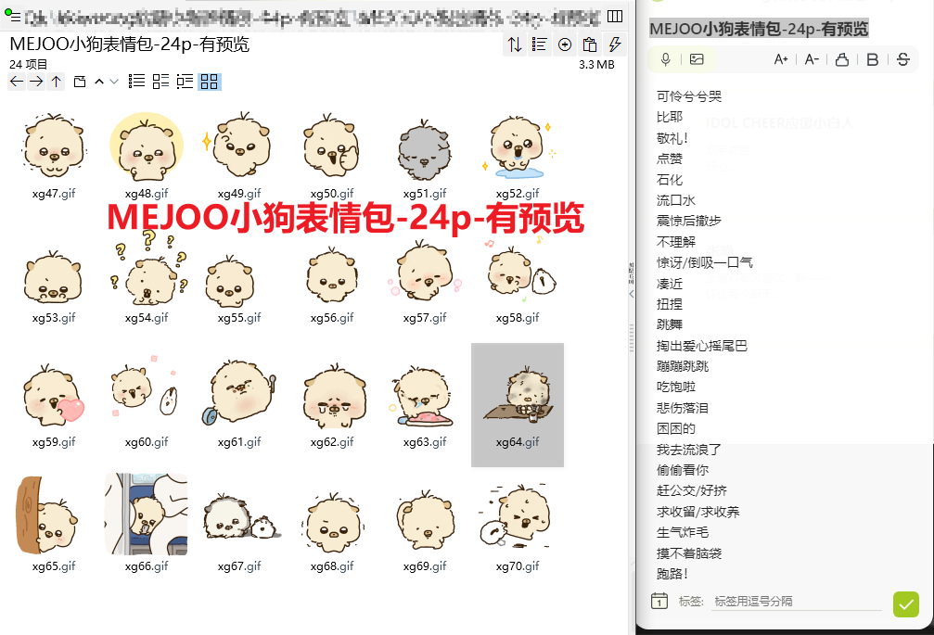
可怜兮兮哭:https://imgbed.heliar.top/i/PQgrXPz2mUL-p9L9_xg47.gif
比耶:https://imgbed.heliar.top/i/umsxSsb-3nxK8N9m_xg48.gif
敬礼！:https://imgbed.heliar.top/i/3TUQ_F8diIdYx0su_xg49.gif
点赞:https://imgbed.heliar.top/i/ZGU-yar3S_TCe_PX_xg50.gif
石化:https://imgbed.heliar.top/i/KESEDXueA104f1Cs_xg51.gif
流口水:https://imgbed.heliar.top/i/ICRGnfr41vi5R83e_xg52.gif
震惊后撤步:https://imgbed.heliar.top/i/z7dmTpN_PyK_ohso_xg53.gif
不理解:https://imgbed.heliar.top/i/3bBsAT4AK0Z5SuuY_xg54.gif
惊讶/倒吸一口气:https://imgbed.heliar.top/i/VRRt8sk5zZyapz7T_xg55.gif
凑近:https://imgbed.heliar.top/i/GQSpCV3Ua3hr6g4S_xg56.gif
扭捏:https://imgbed.heliar.top/i/GUTPZ86YJhkg2SmJ_xg57.gif
跳舞:https://imgbed.heliar.top/i/0SOVIoNpZYclDN1x_xg58.gif
掏出爱心摇尾巴:https://imgbed.heliar.top/i/tbDMj8nYc-k-_EXq_xg59.gif
蹦蹦跳跳:https://imgbed.heliar.top/i/HdnRWDCdK1baZ5KT_xg60.gif
吃饱啦:https://imgbed.heliar.top/i/uvIV6-Cx5T1gV3mX_xg61.gif
悲伤落泪:https://imgbed.heliar.top/i/EnT2MNZFNqzQDIJB_xg62.gif
困困的:https://imgbed.heliar.top/i/rk4z9OZLvCH2YGNr_xg63.gif
我去流浪了:https://imgbed.heliar.top/i/Af34JkyQNz97c9OK_xg64.gif
偷偷看你:https://imgbed.heliar.top/i/K1XTvZs3U33zURCQ_xg65.gif
赶公交/好挤:https://imgbed.heliar.top/i/n8tR1Xd3pvBZIgJO_xg66.gif
求收留/求收养:https://imgbed.heliar.top/i/8xo6JTK4b8tLGPMa_xg67.gif
生气炸毛:https://imgbed.heliar.top/i/A5ozuFDN6BpQo9v2_xg68.gif
摸不着脑袋:https://imgbed.heliar.top/i/v2csBsNeXFK264eB_xg69.gif
跑路！:https://imgbed.heliar.top/i/fao7TdZ-Zh0Yf_sd_xg70.gif

